 | We are recycling – please disregard the back side of any notes. In an aim to reduce waste we are copying on unwanted paper. | 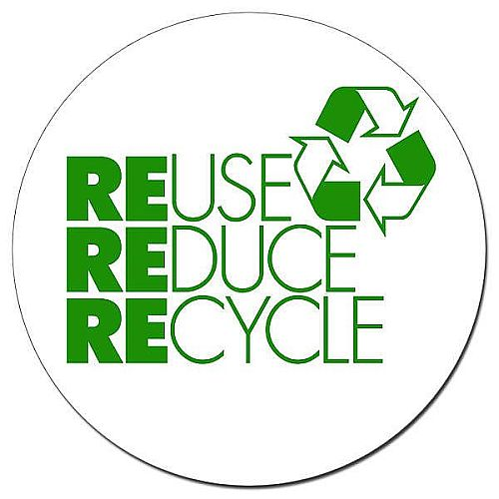
 | NEW PAYMENT SYSTEM as from 14th June 2019  We will now be able to accept payment online from parents. Attached is a new envelope specifically for this with instructions.  You just need to click on the https://cargo-p.schools.nsw.gov.au/ website and the pay now button to make a payment. Please pay close attention to your permission notes with how to record this in the future.  Any accounts marked as CASH – needs to come to the school in cash please. Ie: donations, cooking money. These funds are not banked but rather used for the purpose intended. | 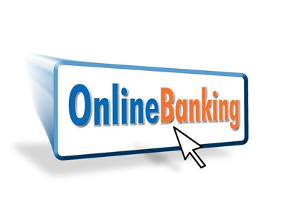
 |  | 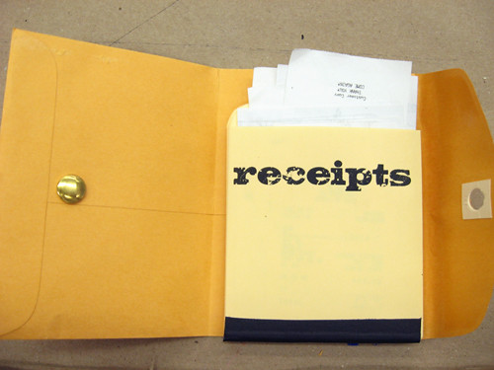
I have included the new envelope for you to send into school once you make an online payment with the receipt number and what you’re paying for. We will reconcile this with your account and send home a receipt. You can also email this as well.

** YOU DO NOT HAVE TO USE THIS – we will still accept cheque’s and cash at school if you prefer.
 | Your statement of account invoices are being sent home with this envelope.  Please start paying off any outstanding balances. We are happy to receive small payments to help reduce the balances owing.  Your statement will have a balance owing in line with item. Please use this line item description in your online payments. Alternatively you can send in cash in your old envelopes that will still be used for cash payments.  We would appreciate payment as soon as possible. | 