 | Education & Book Week at Cargo PS  will be held Tuesday 13th August 2019 | 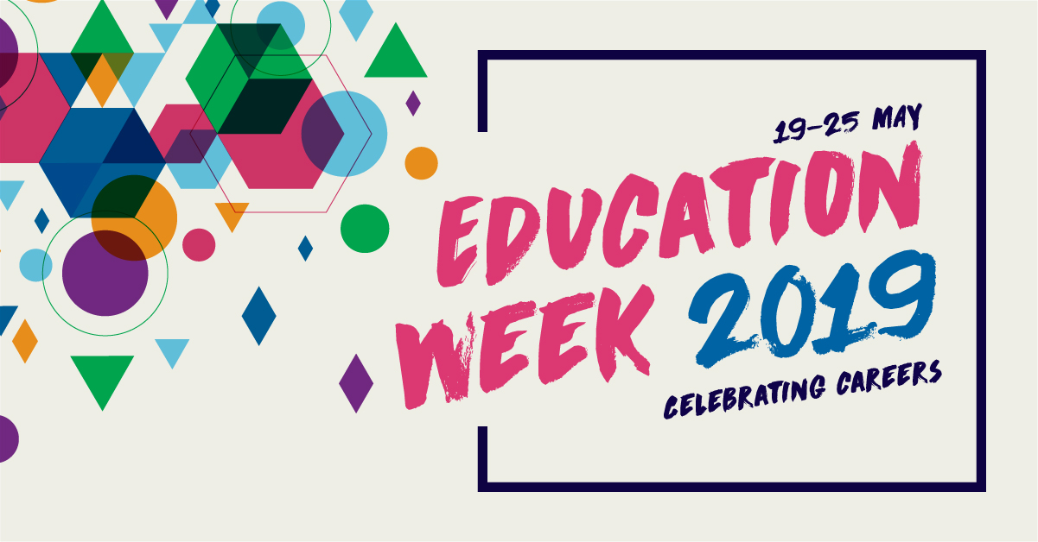  13 August 19
We will be holding an afternoon tea with the community family and friends from 2pm under the COLA at school.
Please come along and bring your family to watch our children display their talents.

 | All children will write a story based on their SUPER POWERs and then read this to our audiaence.  We will demonstrate some of our musical talents being nurtures in music class  All children will parade as their favourite super hero. | 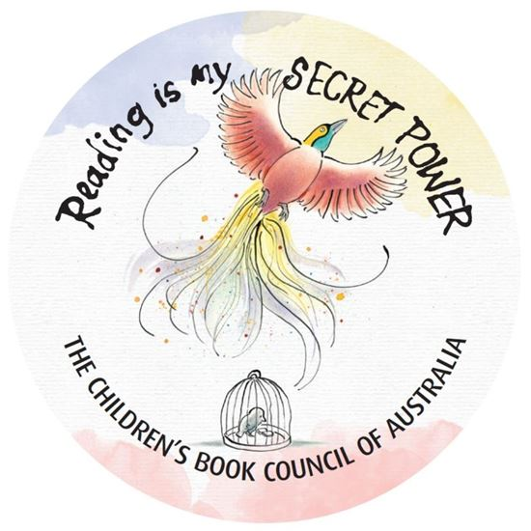
We look forward to seeing you at school
2pm
Tuesday 13th August 2019

Rebecca Horan
Principal

