Whats On! - TERM 3 and 4 2019

We would like to thank Gregory Doherty of Arête Survey Solutions for his very generous donation towards our schools cooking program. This money will support our cooking in term 4 2019.

Lake Burrendong Sport & Recreation camp – whole school excursion 28/29 October 2019 (week 3 Term 4)
This planned excursion in term 4, will involve all children from kinder to year 6 and all staff (Bec, Bec, Tahlia, Mandy, Ian, Kay & Claudette)
We will be attending with other small school children and be actively involved in lots of activities on offer.
We will be camping overnight and travelling by bus.

We are happy to deduct the money already paid for cooking in term 4 to this excursion, thanks to Gregory’s generosity. We have done this for any families going.

 | Please find attached your Burrendong envelope with your families total payment cost and any payments already made.  Please make small payments regularly to avoid a large payment at the end. Just write down the amount and date and we will receipt it. | 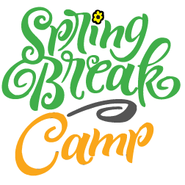
The excursion will need to be paid for by the end of term.
If you haven’t already done so, please return the EOI.

Kind regards
Mandy & Bec

